Otorgamiento
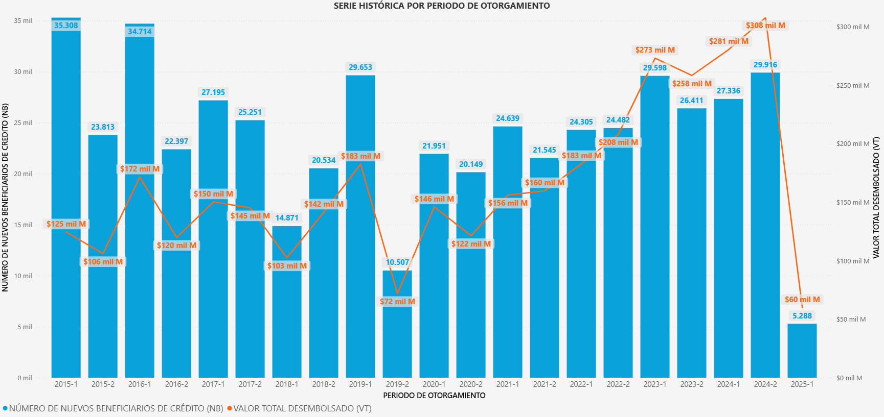

PERIODO OTORGAMIENTO | NÚMERO DE NUEVOS BENEFICIARIOS DE CRÉDITO (NB) | VALOR DESEMBOLSADO POR CRÉDITO (VC) | VALOR DESEMBOLSADO POR SUBSIDIO DE SOSTENIMIENTO (VS) | VALOR TOTAL DESEMBOLSADO (VT) | NÚMERO DE GIROS (NG) | VALOR PROMEDIO DESEMBOLSADO POR MATRÍCULA (VPM)
2015-1 | 35.308 | 115.440.792.235 | 9.095.610.831 | 124.536.403.066 | 45.831 | 3.346.922
2015-2 | 23.813 | 104.886.565.748 | 1.220.818.897 | 106.107.384.645 | 25.176 | 4.510.990
2016-1 | 34.714 | 164.466.456.512 | 7.059.229.808 | 171.525.686.320 | 43.060 | 4.790.217
2016-2 | 22.397 | 115.655.916.032 | 4.300.529.958 | 119.956.445.990 | 28.026 | 4.984.316
2017-1 | 27.195 | 142.457.832.402 | 7.819.365.051 | 150.277.197.453 | 36.274 | 5.074.140
2017-2 | 25.251 | 142.297.798.151 | 3.001.293.606 | 145.299.091.757 | 29.109 | 5.245.177
2018-1 | 14.871 | 99.768.646.631 | 2.820.220.661 | 102.588.867.292 | 18.228 | 6.418.088
2018-2 | 20.534 | 136.746.286.945 | 4.801.693.713 | 141.547.980.658 | 26.336 | 6.119.696
2019-1 | 29.653 | 175.010.061.932 | 7.596.379.041 | 182.606.440.973 | 38.329 | 5.750.324
2019-2 | 10.507 | 70.112.435.818 | 1.899.321.910 | 72.011.757.728 | 12.775 | 6.416.845
2020-1 | 21.951 | 137.370.773.856 | 8.605.648.181 | 145.976.422.037 | 31.552 | 6.104.040
2020-2 | 20.149 | 116.103.111.868 | 5.403.146.150 | 121.506.258.018 | 26.015 | 5.707.252
2021-1 | 24.639 | 146.619.578.056 | 9.518.522.490 | 156.138.100.546 | 35.075 | 5.796.358
2021-2 | 21.545 | 153.078.482.760 | 6.721.882.291 | 159.800.365.051 | 28.727 | 6.598.062
2022-1 | 24.305 | 173.625.098.559 | 9.342.003.850 | 182.967.102.409 | 33.224 | 6.717.108
2022-2 | 24.482 | 200.016.642.727 | 8.012.115.349 | 208.028.758.076 | 32.094 | 7.265.038
2023-1 | 29.598 | 262.243.566.328 | 11.010.919.592 | 273.254.485.920 | 38.320 | 8.011.641
2023-2 | 26.411 | 251.636.079.895 | 6.855.642.184 | 258.491.722.079 | 31.345 | 8.024.066
2024-1 | 27.336 | 267.933.608.157 | 12.703.201.963 | 280.636.810.120 | 35.584 | 8.630.316
2024-2 | 29.916 | 298.486.181.634 | 9.426.775.331 | 307.912.956.965 | 34.979 | 8.676.093
2025-1 | 5.288 | 59.960.813.309 | 0 | 59.960.813.309 | 5.348 | 10.311.283

Renovación
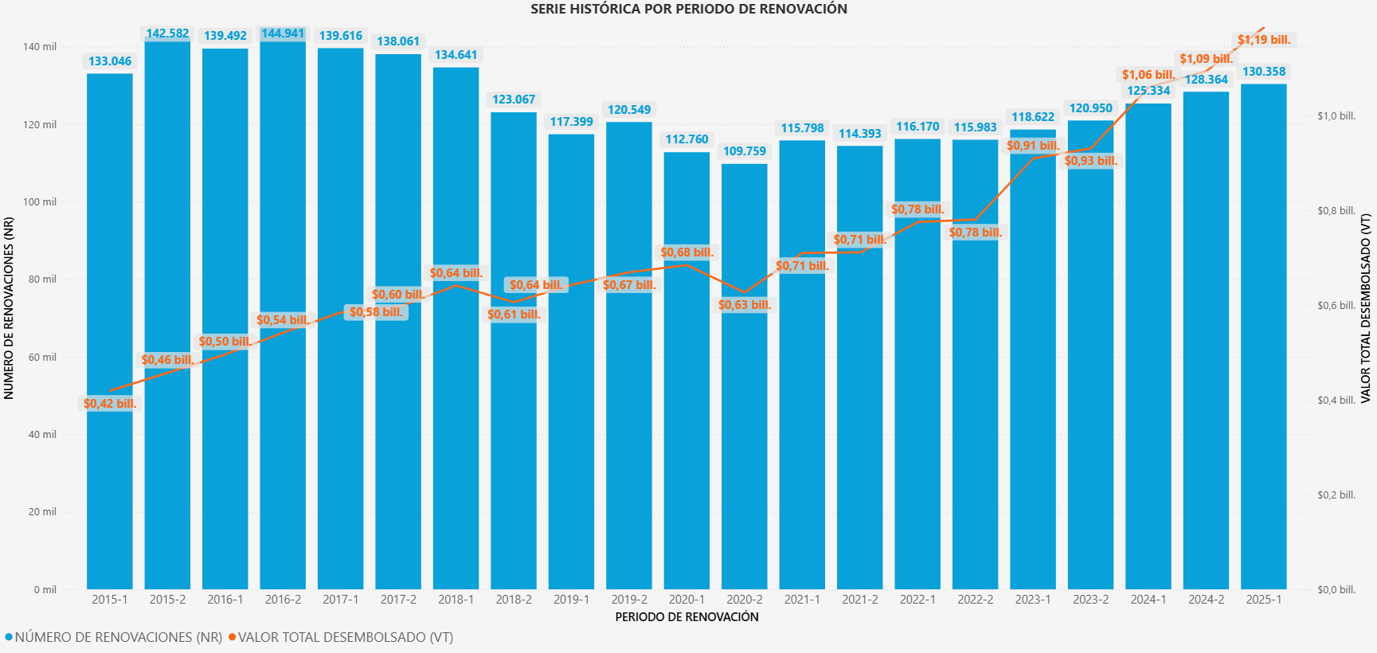

PERIODO RENOVACIÓN | NÚMERO DE RENOVACIONES (NR) | VALOR DESEMBOLSADO POR CRÉDITO (VC) REN | VALOR DESEMBOLSADO POR SUBSIDIO DE SOSTENIMIENTO (VS) REN | VALOR TOTAL DESEMBOLSADO (VT) REN | NÚMERO DE GIROS (NG) REN
2015-1 | 133.046 | 370.123.483.537 | 49.009.754.828 | 419.133.238.365 | 191.044
2015-2 | 142.582 | 407.405.281.344 | 49.567.098.327 | 456.972.379.671 | 204.587
2016-1 | 139.492 | 450.088.336.611 | 45.694.781.375 | 495.783.117.986 | 193.588
2016-2 | 144.941 | 497.614.863.810 | 44.128.976.033 | 541.743.839.843 | 198.257
2017-1 | 139.616 | 542.398.277.061 | 42.133.266.624 | 584.531.543.685 | 187.260
2017-2 | 138.061 | 554.385.162.850 | 41.494.135.149 | 595.879.297.999 | 185.657
2018-1 | 134.641 | 600.662.908.206 | 40.741.246.251 | 641.404.154.457 | 179.516
2018-2 | 123.067 | 569.952.512.240 | 36.060.641.435 | 606.013.153.675 | 162.714
2019-1 | 117.399 | 607.317.138.267 | 35.407.251.367 | 642.724.389.634 | 155.293
2019-2 | 120.549 | 632.166.745.908 | 37.184.362.535 | 669.351.108.443 | 160.643
2020-1 | 112.760 | 645.576.891.930 | 38.756.823.904 | 684.333.715.834 | 153.625
2020-2 | 109.759 | 585.969.261.568 | 40.784.494.655 | 626.753.756.223 | 152.847
2021-1 | 115.798 | 663.402.878.854 | 46.494.668.717 | 709.897.547.571 | 164.495
2021-2 | 114.393 | 662.702.908.836 | 48.443.677.279 | 711.146.586.115 | 164.282
2022-1 | 116.170 | 722.239.893.219 | 52.892.121.479 | 775.132.014.698 | 168.375
2022-2 | 115.983 | 725.658.063.406 | 54.843.965.782 | 780.502.029.188 | 169.467
2023-1 | 118.622 | 845.273.682.701 | 64.373.420.117 | 909.647.102.818 | 173.799
2023-2 | 120.950 | 865.488.268.960 | 65.249.066.769 | 930.737.335.729 | 175.935
2024-1 | 125.334 | 986.464.428.769 | 73.516.206.996 | 1.059.980.635.765 | 180.868
2024-2 | 128.364 | 1.024.671.020.915 | 69.262.693.151 | 1.093.933.714.066 | 181.285
2025-1 | 130.358 | 1.125.536.974.986 | 60.414.451.180 | 1.185.951.426.166 | 178.506

